**French**

*Salut! Core Unit 1*

**Year 3**

**Autumn Term**

**Background information**

This unit gives children an introduction to the French language. It includes some basic vocabulary which will enable them to count up to 10 and introduce themselves in French. As well as talking about themselves, children will learn to introduce their immediate family in French. The unit ends with a simple story which recaps some of the vocabulary from the unit as a whole.

**Key Vocabulary:**

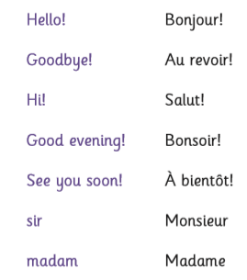

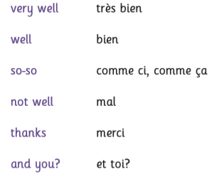

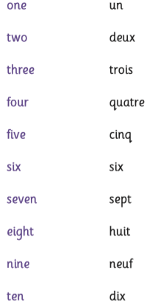

**Knowledge and Understanding**

* To be able to greet each other confidently, and introduce themselves and their family.
* Understand the numbers 1-10 and use them to say how old they are.
* Understand and respond to some simple questions and instructions.
* Recognise some words in their written form and pronounce them accurately.

