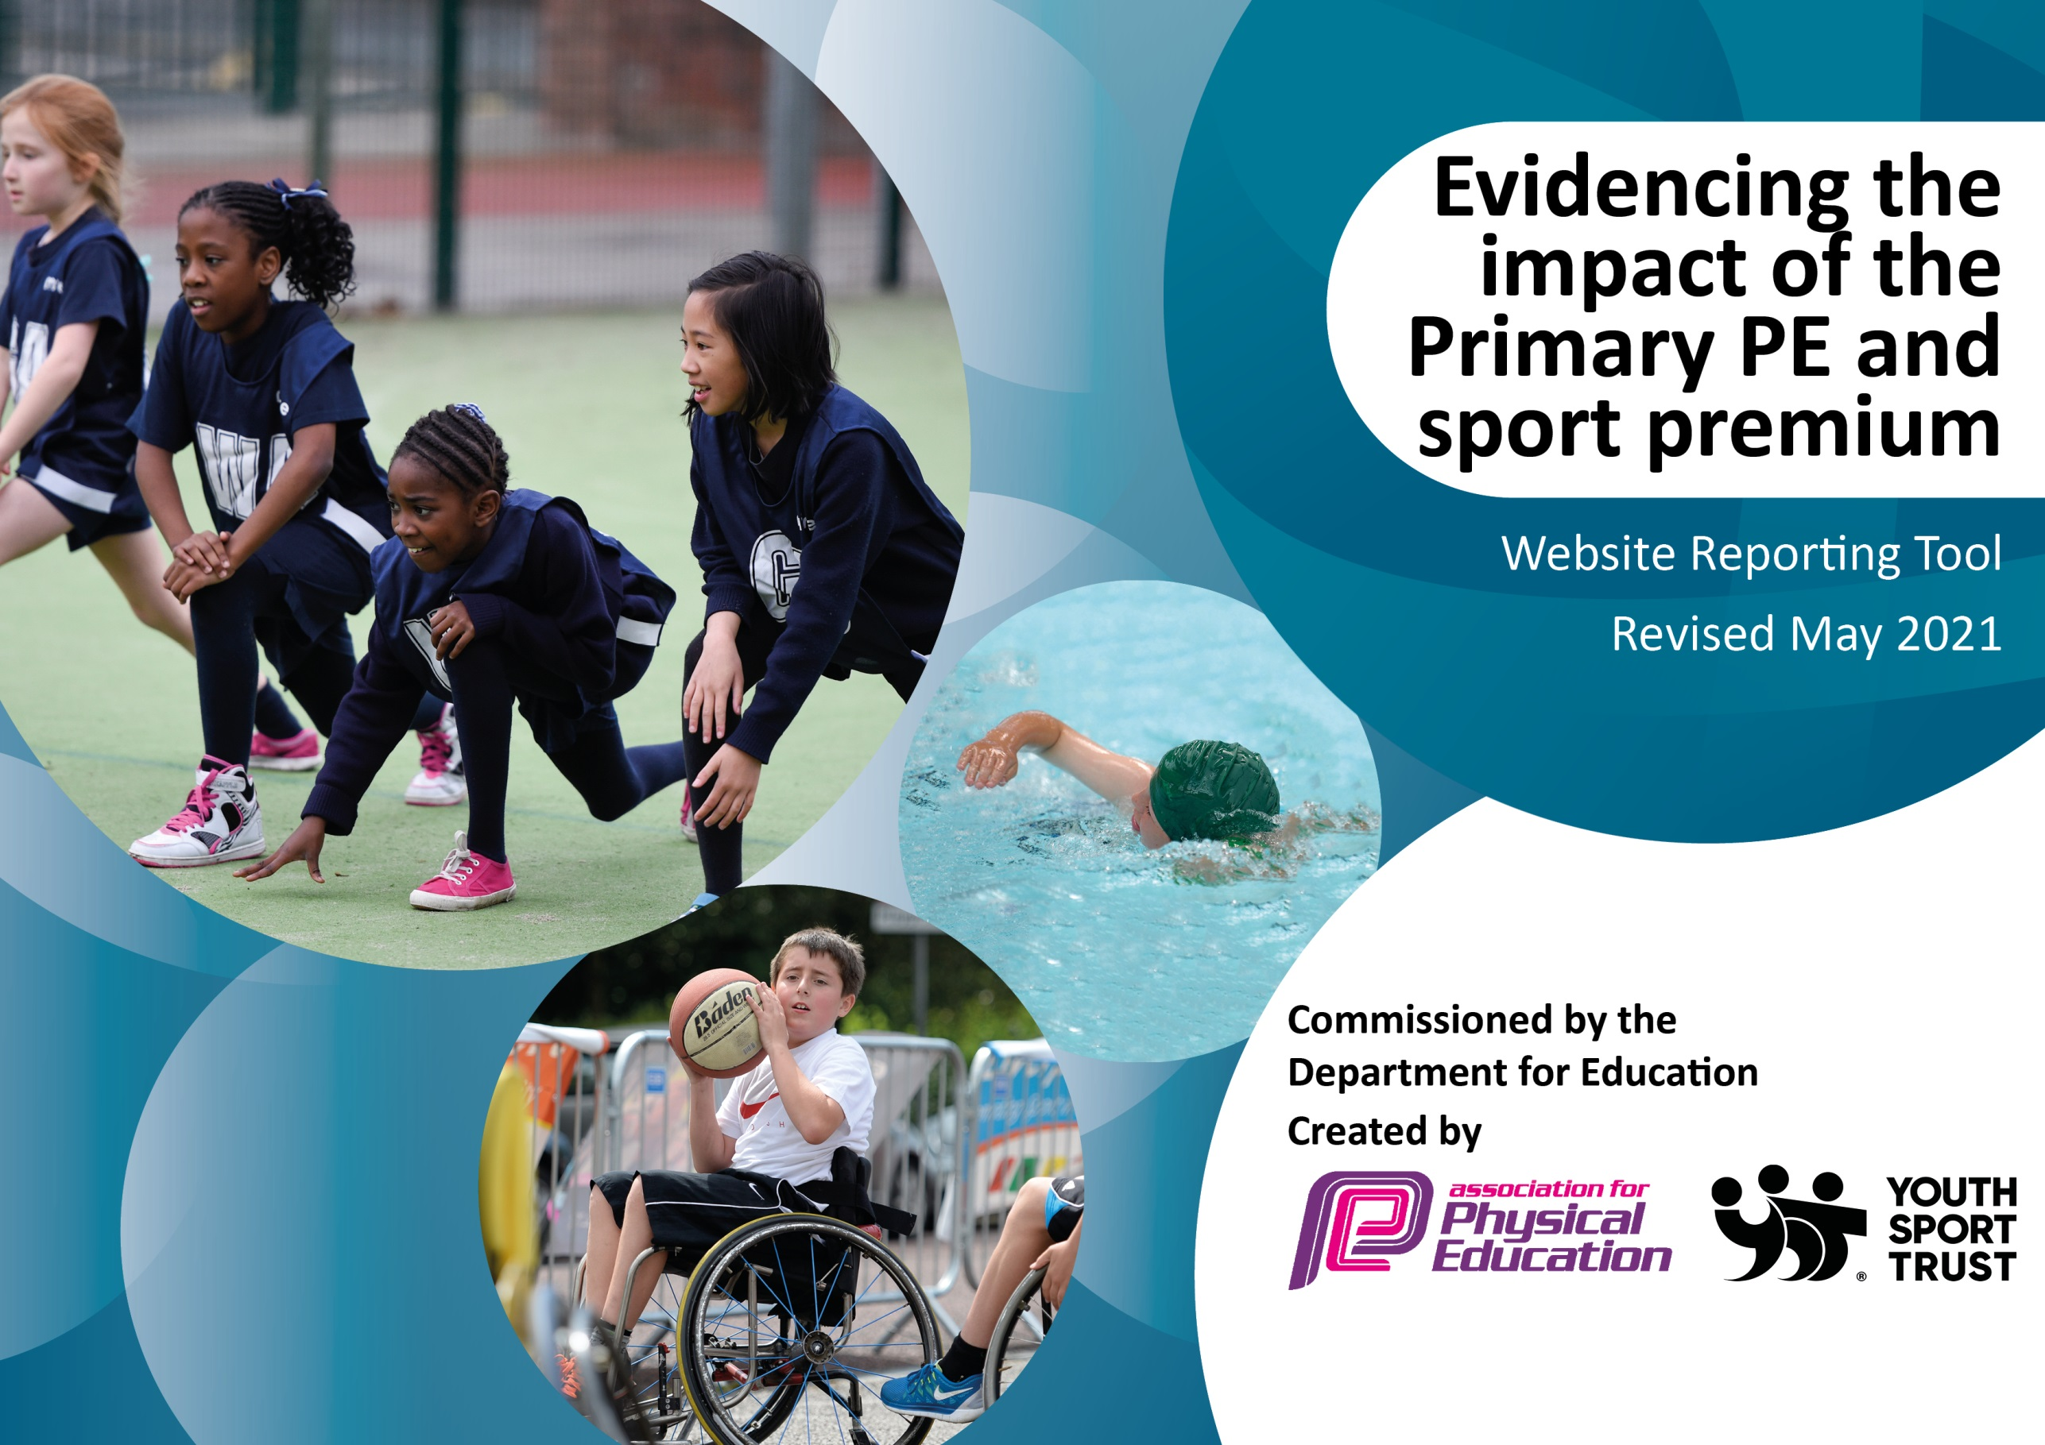

It is important that your grant is used effectively and based on school need. The Education Inspection Framework (Ofsted 2019 p64) makes clear there will be a focus on ‘whether leaders and those responsible for governors all understand their respective roles and perform these in a way that enhances the effectiveness of the school’.

Under the Quality of Education criteria (p41) inspectors consider the extent to which schools can articulate their curriculum (INTENT), construct their curriculum (IMPLEMENTATION) and demonstrate the outcomes which result (IMPACT).

To assist schools with common transferable language this template has been developed to utilise the same three headings which should make your plans easily transferable between working documents.

Schools must use the funding to make additional and sustainable improvements to the quality of Physical Education, School Sport and Physical Activity (PESSPA) they offer. This means that you should use the Primary PE and sport premium to:

- Develop or add to the PESSPA activities that your school already offer
- Build capacity and capability within the school to ensure that improvements made now will benefit pupils joining the school in future years
- The Primary PE and sport premium should not be used to fund capital spend projects; the school’s budget should fund these.
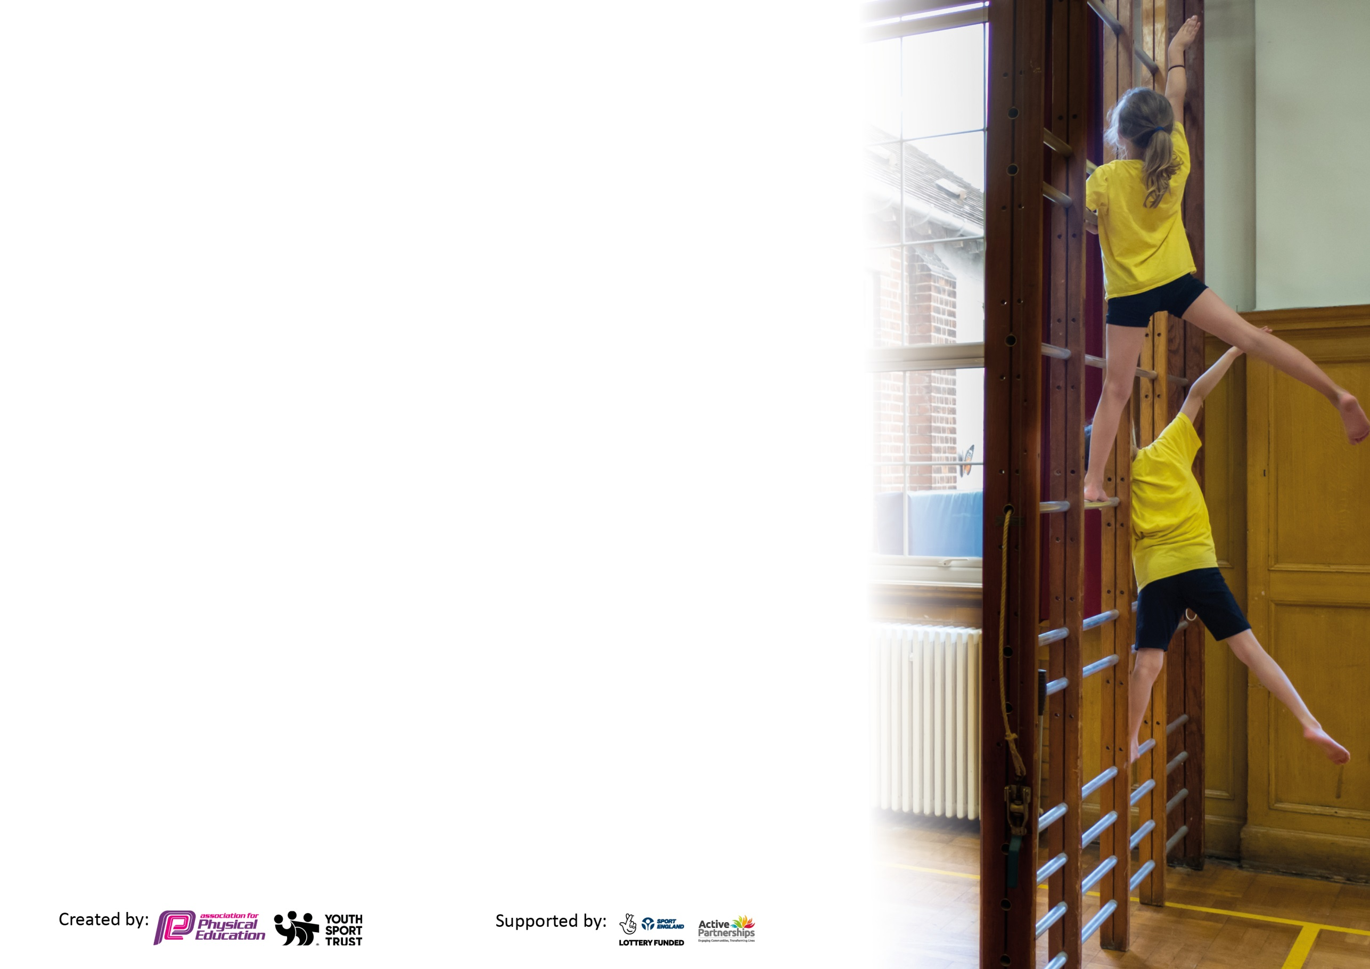
Please visit gov.uk for the revised DfE guidance including the 5 key indicators across which schools should demonstrate an improvement. This document will help you to review your provision and to report your spend. DfE encourages schools to use this template as an effective way of meeting the reporting requirements of the Primary PE and sport premium.

We recommend you start by reflecting on the impact of current provision and reviewing the previous spend.

Schools are required to publish details of how they spend this funding, including any under-spend from 2019/2020, as well as on the impact it has on pupils’ PE and sport participation and attainment by the end of the summer term or by 31st July 2021 at the latest.

We recommend regularly updating the table and publishing it on your website throughout the year. This evidences your ongoing self-evaluation of how you are using the funding to secure maximum, sustainable impact. Final copy must be posted on your website by the end of the academic year and no later than the 31st July 2021. To see an example of how to complete the table please click HERE.

Please note: Although there has been considerable disruption in 2021 it is important that you publish details on your website of how you spend the funding - this is a legal requirement.
Support for review and reflection - considering the 5 key indicators from DfE, what development needs are a priority for your setting and your pupils now and why? Use the space below to reflect on previous spend and key achievements and areas for development.

N.B. In this section you should refer to any adjustments you might have made due to Covid-19 and how these will influence further improvement.
Key achievements to date until July 2022: | Areas for further improvement and baseline evidence of need:
Sports competition has been back up and running so children have been able to compete against other schools and take part in sports leagues.
Swimming has taken place for those year groups who missed out due to covid- Years 5, 4 and 3- this will go back to year 2 from next year.
District sports took place where we took a KS2 team to complete
Achieved Bronze in the Sainsbury’s games.

Did you carry forward an underspend from 2020-21 academic year into the current academic year?
NO

Meeting national curriculum requirements for swimming and water safety.  N.B Complete this section to your best ability. For example you might have practised safe self-rescue techniques on dry land which you can transfer to the pool when school swimming restarts.  Due to exceptional circumstances priority should be given to ensuring that pupils can perform safe self rescue even  if they do not fully meet the first two requirements of the NC programme of study. | We have taken 3 year groups swimming this year to ensure no children miss out due to Covid. They have attended intensive swimming courses over 2 week swimming daily to build their skills and confidence further.
What percentage of your current Year 6 cohort swim competently, confidently and proficiently over a distance of at least 25 metres?  N.B. Even though your pupils may swim in another year please report on their attainment on leaving primary school at the end of the summer term 2021.  Please see note above. | 75%
What percentage of your current Year 6 cohort use a range of strokes effectively [for example, front crawl, backstroke and breaststroke]?  Please see note above. | 70%
What percentage of your current Year 6 cohort perform safe self-rescue in different water-based situations? | 60%
Schools can choose to use the Primary PE and sport premium to provide additional provision for swimming but this must be for activity over and above the national curriculum requirements. Have you used it in this way? | Yes, we have used this to build water confidence and ensure our children can all swim.

Action Plan and Budget Tracking
Capture your intended annual spend against the 5 key indicators. Clarify the success criteria and evidence of impact that you intend to measure to evaluate for pupils today and for the future.

Academic Year: 20221/22 | Total fund allocated: £17,500 TBC | Date Updated: Autumn 2021
Key indicator 1: The engagement of all pupils in regular physical activity – Chief Medical Officers guidelines recommend that primary school pupils undertake at least 30 minutes of physical activity a day in school |  |  |  | Percentage of total allocation:
 |  |  |  | %
Intent | Implementation |  | Impact
To involve all children in physical activity and in a range of sporting opportunities. | Monthly Inter-form challenges to be completed- funding used to purchase resources where needed. | £500 to support implementation of the different sports and challenges. | All children will feel valued in taking part in competitive sport | 2.86%  Sustainability and suggested next steps:  The children and staff have taken part in these events to build confidence and competitive spirit- this will be implemented again next year but we plan to involve the parents and carers more.
To ensure PE and extra-curricular clubs are resourced with suitable and safe equipment. | New ropes to be purchased and installed in the hall.  PE equipment audit to be carried out with replacement equipment purchased.  General equipment replacement- £1000  Basketball nets X2- £400  Ropes X4- £500  Playground markings £2000 | £3900 | High quality delivery of PE lessons and extra curricular clubs with appropriate and enough equipment to include all children taking part. | 22.29%  Sustainability and suggested next steps:  New equipment has been purchased and replaced. The ropes are useable and all other equipment has been used to enhance and inspire our children. Playground markings mean our children can see the lines of courts when playing in matches.
Key indicator 2: The profile of PESSPA being raised across the school as a tool for whole school improvement |  |  |  | Percentage of total allocation:
 |  |  |  | %
Intent | Implementation |  | Impact
To raise the profile of PESSPA across the school- FOREST SCHOOL | JH to work closely with class teachers to promote more outdoor learning opportunities including access to our woodland walk for Forest school | £500 to continue to build our bank of resources to support outdoor learning. | Children learn better when they are outside. With a canopy that allows the woods to be used in all weathers and various other equipment- children can develop their physicality by learning more outdoors. | 2.86%  Sustainability and suggested  next steps:  There has been more opportunity for outdoor learning including treasure hunts and orienteering style activities. Staff have been more willing to engage with outdoor learning and have woven this through their teaching and learning for example- year 6 played Quidditch linked to Harry Potter. Children have developed hunts and games for younger pupils and each other to play.

Key indicator 3: Increased confidence, knowledge and skills of all staff in teaching PE and sport |  |  |  |  |  |  |  | Percentage of total allocation:
 |  |  |  |  |  |  |  | %
Intent |  | Implementation |  |  |  | Impact
 | Upskill existing staff member so he can raise the profile of PESSPA and attainment in sport for all our children. |  | JH to complete his level 5 course following disruption last year. |  | Payment from last Sports Premium funding |  | JH will gain further confidence in delivery of high quality PE across the school including extra curricular opportunities. |  | Sustainability and suggested  next steps:  JH has now completed his level 5 qualification and is using his knowledge to impact on the quality of PE teaching across the school.
 | Class teachers to support and teach their own PE sessions at least half termly to ensure skill level is maintained and confidence in teaching PE is high- this can include outdoor learning opportunities. |  | JH to advise staff they must be teaching at least one session of PE every half term- this can include outdoor learning opportunities. |  | £250 towards any resources requested. |  | All staff will be confident in delivery PE teaching without hesitation. |  | 1.43%  Sustainability and suggested  next steps:  This is an area that we will continue to build on next year as staff still lack confidence sometimes- consider training for all staff for next year.
Key indicator 4: Broader experience of a range of sports and activities offered to all pupils |  |  |  |  |  |  |  | Percentage of total allocation:
 |  |  |  |  |  |  |  | %
Intent |  | Implementation |  |  |  | Impact
 | School to be part of the Sainsbury’s games. |  | JH to join the local Sainsbury’s games which will be running virtual competitions foe the time being. |  | £250 |  | Children will still be able to take part in some form of competitive sport with other schools all be it virtually. |  | 1.43%  Sustainability and suggested  next steps:  We have been able to compete in competitions face to face which the children have hugely benefited from. It has helped to develop our children’s skills and competitiveness which they lacked due to limited experiences because of Covid.
 | To give children the best possible sporting opportunities through quality teaching and learning. |  | Mr Holmes to continue as our Sports TA- teaching high quality sport and fitness to all year groups. |  | £5,800 |  | Children will experience high quality lessons and extra-curricular clubs that allows children to progress and develop a love of sport and fitness. |  | 33.14%  Sustainability and suggested  next steps:  Mr Holmes is a fantastic sports coach who dedicates his time and effort to supporting all of our children in their learning. This has continue this year.
 | To educate our children in maintain healthy lifestyles and trying new sports. |  | Year 6 will take part in a half term of Martial arts to develop a new skill that develops Focus, self Discipline, Respect, Confidence.  Honesty, Communication. This skills are under developed due to Covid and limited Sports access during the last 2 years. |  | £1,500 |  | Children will develop core and life skills that have been under developed due to Covid in preparation for secondary school and the wider world. |  | 8.57%  Sustainability and suggested next steps:  Year 6 successfully took part on Martials Arts- this was then cascaded down to year 4 and 5. All classes thoroughly enjoyed the sessions and learnt new skills. Some children have even continued with this outside of school.
 | To ensure all of our children experience swimming and can swim 25 metres before they leave in year 6 (this is a big catch up programme due to Covid restrcictions)- Currently still trying to find a willing pool with enough space and time. |  | Year 5 and 4 to be the focus groups for this year to catch up on missed swimming opportunities following Covid restrictions. |  | £5,000 |  | Children will be able to swim 25 metres and feel safer around water. |  | 28.57%  Sustainability and suggested next steps:  We have taken 3 year groups swimming for intensive courses lasting 2 weeks to ensure all our children can swim by the time they leave us.
Additional achievements:

-In house sports day to take place.
- Extra- curricular clubs have run for the summer term including football, netball, rounders, cricket and running club.
- Tennis club run by outside agency.
- Martial arts club run by outside agency
- children competed at District Sports and a range of other competitions across the year.

Key indicator 5: Increased participation in competitive sport |  |  |  | Percentage of total allocation:
 |  |  |  | %
Intent | Implementation |  | Impact
As many children as possible to take part in competitive sports across the school and year. | Schools to take part in competitive sports through the Harpenden Sports Association | Part of our HPP offer | Children to gain confidence in competing and feeling comfortable and confident to do so.  Children to want to represent our school in a variety of competitions and ports. | 0%  Sustainability and suggested next steps:  Children have taken part in many competitions and leagues across the year. We trailed a new approach to extra-curricular clubs where every child was encouraged to sign up to at least 1 club- most children did but a few could not attend after school so we will include lunch times so other children can attend, develop their skills and then take part on competitive sport representing the school.

Signed off by
Head Teacher:
Date:
Subject Leader:
Date:
Governor:
Date:

