Some ways to practise phonics

- What we can do is focus on certain phonics that are sticking points and write them in words he knows, highlighting the sound. You could write them down and position in the kitchen, or back of bathroom door.

Eg ‘ear’
hear

fear

beard
Further to this you could write the sound buttons underneath.
2. Make up a rhyme or the action, so if it is ear (action is pulling ear lobe while you say it). Then when your child is reading that sound you can move towards just doing the action which helps trigger their memory..
3.Play phonics matching games, write out the phonemes on cards and place around the room, so they have to look for it and bring it back, you could time how quickly they can be retrieved, this makes it fun and moves away from the focus on just reading the sound.
Or Bingo, you can be the bingo caller and say different sounds and they tick them off they have them. Quite nice for all the family, you could swap round who is the bingo caller.
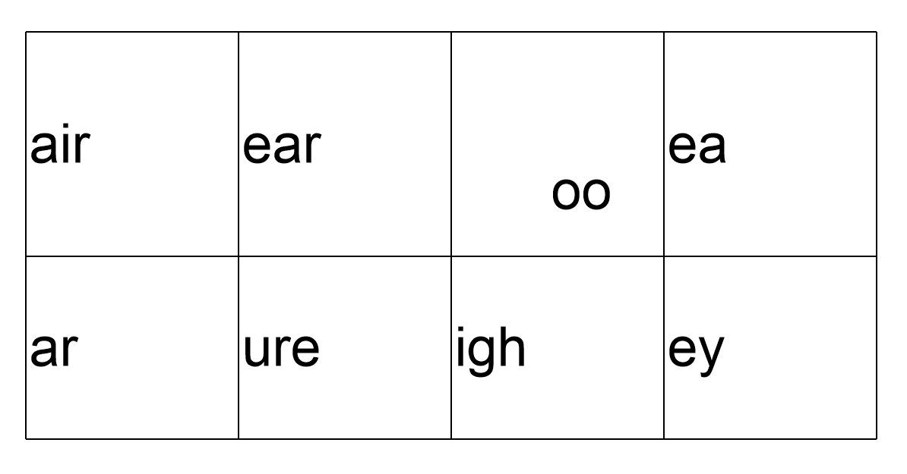
4. Practise the sound on phonics play https://www.phonicsplay.co.uk, Click on resources and you can tailor your own ‘Buried treasure’ game just using the phonemes you need to practise.
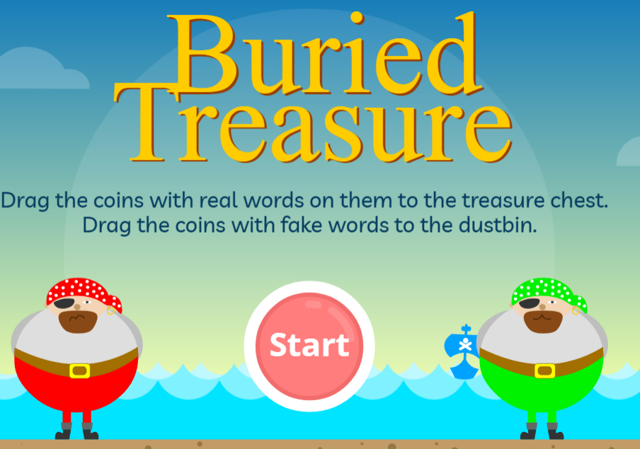
5. When reading books together, make a point of showing words with this phoneme in, and show how to read it by breaking the word down, sounding out each sound yourself.

